Candidate Valuation & Scoring Framework

To quantify candidate capability without relying solely on aptitude or subjective group discussion marks with score called the Participant Valuation Index (PVI):

PVI = ($0.4 × Aptitude$) + ($0.25 × GD$) + ($0.35 × Resume/ Profile$)

Score Components

- Aptitude Score (40% weight, 0–100 scale):
  - 50% Quantitative logic and algorithmic problem-solving.
  - 50% Core CS fundamentals (data structures, web basics, debugging pseudocode).
- Group Discussion Score (25% weight, 0–100 scale):
  - Evaluated by judges across three metrics on a 1–5 scale: Technical Articulation, Collaborative Problem-Solving, and Discussion Moderation.
  - Normalized to a 100-point scale.
- Profile & Practical Skill Score (35% weight, 0–100 scale):
  - Extracted from the resume:
    - Base score (40 pts): Verified skill stack declaration (Frontend, Backend, ML, UI/UX).
    - Portfolio verification (30 pts): Active GitHub repository or deployed project link.
    - Prior hackathon experience (30 pts): Documented participation or placement in previous hackathons.

Base Price Tiers
Teams receive a virtual budget of 1,000 points. Candidates enter the auction under one of four tiers based on their PVI and declared skillset:

Tier | Eligibility Criteria | Base Price
Tier 1 (Marquee / All-Rounders) | PVI >= 85 with full-stack or dev + design versatility | 100 pts
Tier 2 (Core Specialists) | PVI 70–84 with proven backend, systems, or ML capability | 60 pts
Tier 3 (Design & Pitch Leads) | PVI 60–69 with UI/UX portfolio or high GD articulation score | 40 pts
Tier 4 (Emerging Developers) | PVI < 60, junior/early-semester participants | 20 pts

UI/UX & Component Specifications

A. Captain Console (/captain)
The Captain Console provides authenticated team captains with bidding controls, personal budget constraints, and current squad composition.

- Header Bar:
  - Logged-in team name.
  - Live purse balance.
  - Current squad fill status (e.g., 3 / 5 Filled).
  - Global synchronized countdown timer.

- Current Bidding Arena (Left Panel):
  - Candidate Card: Name, college year/branch, PVI score, primary domain tag, and listed technical proficiencies.
  - Bid Status: Current highest bid amount, leading team badge, and local status indicator (LEADING, OUTBID, or INACTIVE).
  - Action Controls: Two dynamic bid buttons (BID +10, BID +25) and a PASS button. Buttons automatically disable when the next increment violates the purse reserve formula.

- Squad Summary & Constraint Tracker (Right Panel):
  - Roster List: Displays 5 sequential slots with candidate name, assigned role, and purchase cost.
  - Skill Coverage Matrix: Checklist tags (Frontend, Backend, AI/ML, UI/Pitch) that change from gray to green as acquired candidates cover those disciplines.
  - Reserve Guardrail Indicator: Shows minimum reserved points required for remaining empty slots and current maximum allowable single bid.

B. Projector & Auditorium Screen (/stage)

- Header Bar:
  - Event name, current round indicator, and high-contrast countdown clock.

- Candidate Spotlight (Left Center):
  - Candidate photo, full name, branch/year, and primary domain badge.
  - PVI rating and initial base price.
  - Active bid callout: Large visual display of current bid value and the name of the leading team.

- All-Squad Standings Table (Top Right):
  - Tabular list of all competing teams showing current purse, slots filled, and active status in the current round (Leading, Outbid, Passed, Full).

- Live Bid Activity Feed (Bottom Right):
  - Chronological audit log showing the last 4 bid increments and the teams that placed them.

- Queue Strip (Bottom Bar):
  - Horizontal carousel previewing the next 3 candidates scheduled for bidding.

C. Admin & Auctioneer Console (/admin)
The master dashboard for running the event, resolving disputes, and advancing the stage.

- Clock Controls: PAUSE, RESET (15s), and +10s EXTEND buttons to control the bidding window manually during stage announcements.
- Stage Hammer:
  - CONFIRM SALE: Finalizes transaction, deducts points from the winning captain, assigns candidate to their roster, and broadcasts an update to all screens.
  - MARK AS UNSOLD: Routes the active candidate to the secondary unsold pool.
  - FREEZE BIDS: Instantly locks captain input buttons during verbal disputes.

- Squad Hardware Monitor:
  - Live connection status and latency ping for each captain’s device (Online, High Latency, Disconnected).

- Dispute & Override Tools:
  - ROLLBACK LAST BID: Reverses the previous bid increment, restores the preceding team as the highest bidder, and refunds points.
  - MANUAL BID ENTRY: Form fields (Team Select, Bid Amount) allowing the admin to input bids verbally communicated from the floor if a captain’s laptop or Wi-Fi fails.
- Queue Manager: Controls for pushing the next candidate to the stage, skipping queue order, or initiating the Unsold Pool round.

Auction Rules & Mathematical Guardrails

Reserve Formula
To prevent teams from bidding all available points on early players and stranding remaining roster spots, the platform enforces an automatic bid cap:

Max Allowable Bid = $Current Balance- (Empty Slots - 1) × Base Price$

Bidding Step Logic
- Bids under 150 points: Minimum increment is 10 points.
- Bids 150 points and above: Minimum increment increases to 25 points to prevent pacing stalls.

Timer Automation
- Standard round duration: 30 seconds per candidate.
- If a bid arrives with fewer than 8 seconds remaining on the clock, the timer resets to 8 seconds.
- The stage does not automatically sell at 0 seconds; the countdown serves as a warning for the auctioneer to trigger the final hammer confirmation.

Roster Constraints
- Target roster size: Exactly 5 participants per team.
- Once a team fills 5 slots, their console disconnects from further bidding loops.

Operational Edge Cases & Recovery Protocols

- Accidental or Double Clicks:
  - Captains cannot submit duplicate bids; clicking the button disables the input until the server acknowledges or rejects the transaction.
  - If a captain makes an erroneous bid, the admin executes ROLLBACK LAST BID. The system reinstates the prior bid state and broadcasts the change across all clients.

- Unsold Candidates:
  - Candidates receiving zero bids after the 15-second timer expires are marked as UNSOLD and sent to Pool 2.
  - Pool 2 candidates are re-introduced in an accelerated round at the end of the day at a 50% discount on their initial base price.

- Device Failure / Disconnection:
  - If a captain’s device disconnects, the Admin hardware monitor flags the status as Disconnected.
  - The admin hits PAUSE CLOCK. The captain raises a physical placard to place bids. The admin logs the bid via MANUAL BID OVERRIDE, which commits the transaction to the database and syncs the projector display.

- Simultaneous Bids (Race Conditions):
  - Bids are processed sequentially using an atomic first-come, first-served lock at the database level.
  - The first bid to register increments the floor; the second near-simultaneous bid is rejected and returns an updated current price to that captain's console.

UI Layouts:

- Captain’s Laptop:

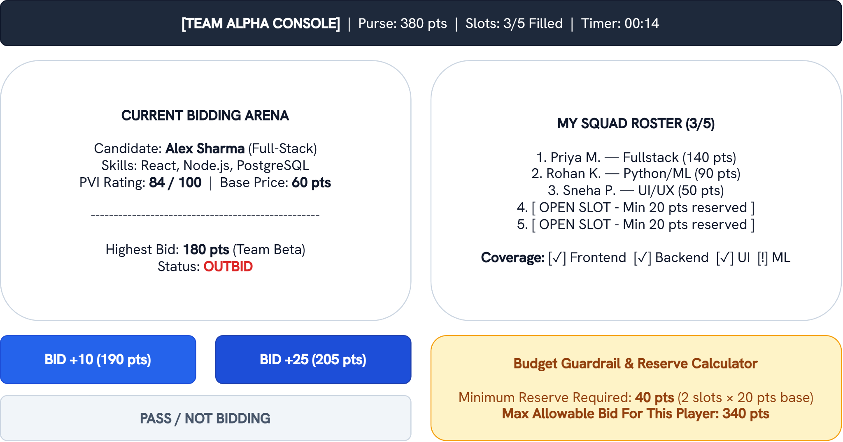

- Projector:

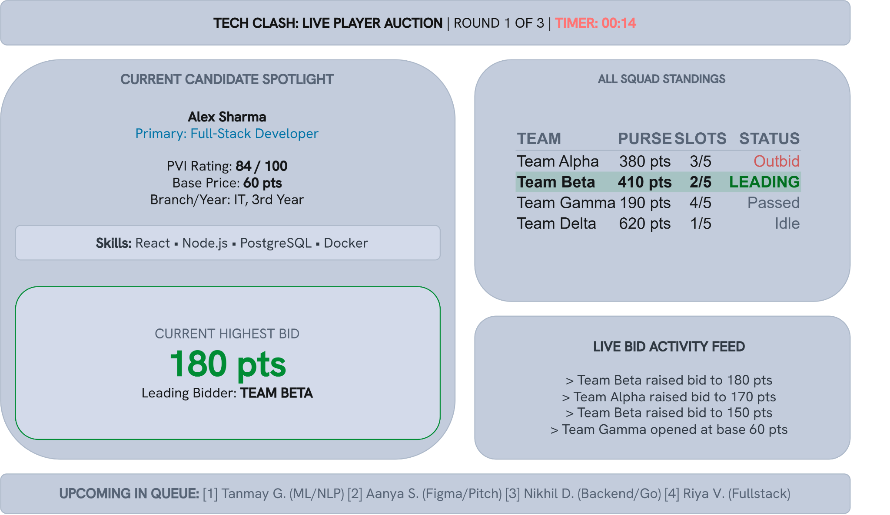

- Admin’s Control:



